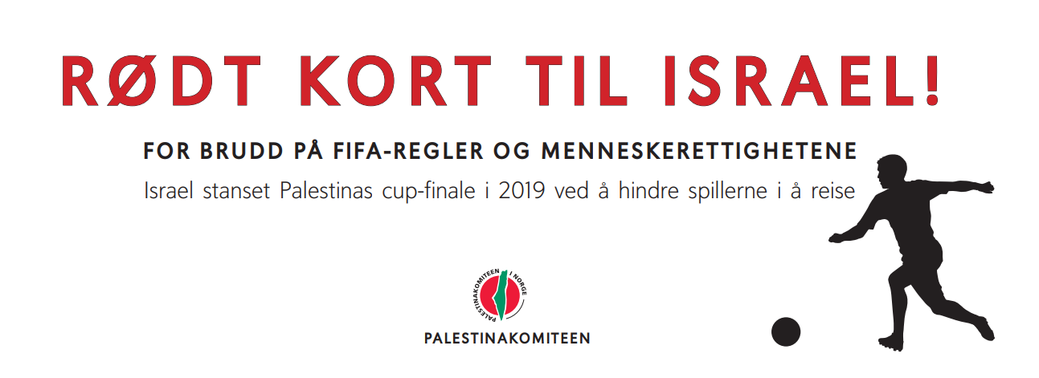

Israel’s football war against Palestine causes a Red Card
By Gerd von der Lippe, professor of sports sociology, Øystein Grønning, leader of AKULBI (cooperation committee for Academic and cultural boycott of the state of Israel), Yonatan Shapira, former pilot in the IDF

On November 11th, the Norwegian men’s football team should play an UEFA match against Israel in Oslo. The match was cancelled the same day due to Covid 19 among Israeli players. This open letter was published in the Norwegian newspaper Dagbladet 10 November:
Red card to Israel’s football war
Football can bridge differences and be a haven. But football can also be an arena for political fights. These days, all of Norway take the collective responsibility to say no to racism, after some ugly episodes, and we say no to abuse because of disposition. Accordingly, when the occupant state of Israel plays in Norway, we are obliged to tell who they are. Because in Israel, football is part of the war against the Palestinians. For this, they deserve a red card.
RED CARD: for stopping the Palestinian cup finals
In 2019, Israel twice stopped the Palestine FIFA Cup Finals by refusing the Gaza team access to the West Bank. The given excuse was security. To Israel, Palestinian football is a threat. It has to be subdued because it brings joy and gives inspires enthusiasm. And Israel can actually do this, as long as no one holds them accountable.
RED CARD: for playing league football on the turf of a different country
Israel play illegally on Palestinian territory. League matches are being played in the illegal Israeli colonies on the West Ban, built in violation of International Law. These matches violate the Geneva Convention and contradict the FIFA rules of conduct.
RED CARD: for bombing Palestinian football fields
Football fields in Gaza have been bombed several times. This is well documented. It is very important to quench Palestinian joy of life and space for playfulness. Therefore, sports facilities are being destroyed, and therefore, Israel denies FIFA the right to train and educate Gaza players.
RED CARD: for murdering Palestinian players
In 2014, 4 boys were downright executed in an Israeli air raid on Gaza, whilst they were playing football at the beach. The episode was filmed and is well known. Around the same time, two teenage Palestinian had their legs shot to splinters on their way home from football practice. They will never walk again, let alone play football. The Israelis claimed they thought the boys had bombs. The Palestinians must be taught that football is deadly when you have Israel as an opponent.
RED CARD: for Apartheid
On the West Bank, Palestinian live under Israeli Military Law, while the Israeli colonists are ruled by Israeli laws, those of a foreign country. Different laws for Israelis and non-Israelis on the same territory is called apartheid according to the UN. Inside Israel, the Nation-State Law of 2018 gives non-Jewish citizens fewer rights than the Jewish ones. This matches the very definition of apartheid according to the UN.
Israel’s league football and national team are integral parts of the occupation of Palestine. This is why we, a limited group of supporters of Human Rights and opponents of apartheid, will show Israel the Red Card at the stadium, ahead of the match on November 11th.

